Contents

Understanding GPU 2

Evolution of GPU 3

Blitter 3

Transformation & Lighting Engine 6

Types of GPU 15

Integrated GPU 15

Discrete GPU 19

GPU Hardware Architecture 27

Processing Clusters 28

GPU Memory Technology 32

Shaders 33

GPU Processing Pipelines 35

3D Graphics Pipeline 35

Compute Pipeline 44

Application Programming Interface 47

Summary 48

1

# Understanding GPU

Graphics Processing Unit (GPU) is a specialized processor in the computer to accelerate the rendering process and display the output image in the display unit. The display unit can be one or more monitors, projectors, Virtual Reality (VR) or Augmented Reality (AR) head mounted displays. It is important to understand the history of GPU and the rich functionality it offers to harness the full potential of this complex piece of hardware using Vulkan API. Though GPU was primarily focused on accelerating games and graphics application, the recent GPUs are capable of accelerating non-visual yet highly parallel workloads such as video processing, physics based simulation, spatial data processing, vision processing and more recently in accelerating deep learning workloads.

This chapter will take you on a journey to understand where it all started and how GPU hardware and software evolved to serve the current acceleration needs in a computing device. We will cover the following topics which would help new graphics or game developers to understand the major breakthroughs in GPU. The following topics will also introduce complex features added along the way in the GPU and their core purpose, more importantly the common jargons graphics professionals and game developers commonly use will be introduced in this chapter. We will revisit some of these complex features in the following chapters in detail. Let’s look at these topics one by one now.

* Evolution of GPU
* Types of GPU
* GPU Hardware Architecture
* Shaders
* 3D Graphics Pipeline
* Compute Pipeline
* Application Programming Interface

## Evolution of GPU

In this section we will look at the early incarnations of current modern GPU. The first one is called the “Blitter”, a special circuit dedicated for performing Boolean operations on bitmaps. The second one is called the “T&L Engine”, a core foundation for the modern GPU pipeline.

### Blitter

It all started with the need for accelerating complex operations in memory such as sprite rendering, flood fill polygons, Raster operations (ROP) where CPU spent majority of the time in fetching data from memory and executing the memory operation on every single pixel in a bitmap. In the early 70’s Xerox introduced Xerox Alto, a first computer designed to support a graphical user interface (GUI) with support for bit block transfer (bit blit / BitBLT) a fundamental programming interface to the display implemented in microcode. Bit block transfer operation usually performed on graphical data (bitmaps), where several bitmaps are combined into one bitmap using a Boolean function.

A dedicated coprocessor called Blitter was introduced to handle complex memory operations to modify the data in the memory. The specialized hardware was capable of rendering 2D sprites and smooth scrolling and was able to support 4 colours and gradually supporting up to 16 million colours by late ‘80s. Blitter became widely popular in arcade game consoles such as ‘Robotron : 2084’ released in ’82.

The 2D acceleration support continued to evolve in the early ‘90s with the introduction of Microsoft’s windows operating system with graphical user interface.

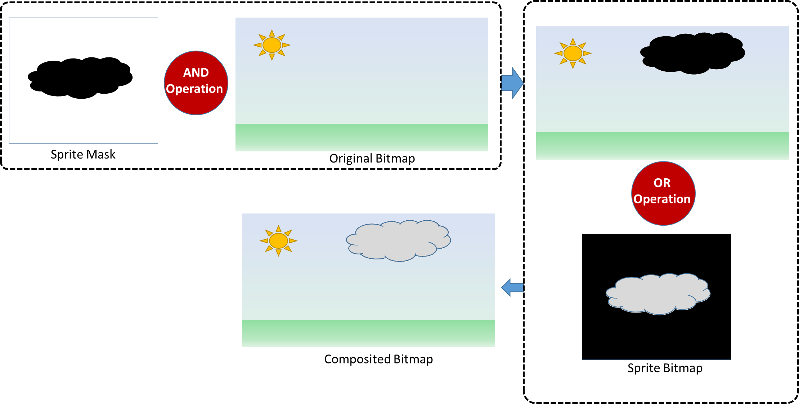

Figure 1: ROP operations to add a sprite to background image

The above diagram illustrates how a sprite (cloud) is added to a background. The first blitter function takes the mask of the sprite and performs an AND raster operation (ROP) with the background image. Then the second blitter function takes the sprite bitmap and performs an OR raster operation on the same location. The resultant background image now contains just the cloud sprite without the black background color in the sprite bitmap. The application can perform this operation on every frame with a slight x offset to simulate the cloud moving in the static background.

The following diagram (Figure 2) illustrates a high level view of a computer system. The graphics subsystem takes inputs from CPU, processes them and generates a visual output. In the beginning GPUs are mainly used to accelerate 2D workloads, perform ROPs, render 2D sprites and update the display as fast as possible.

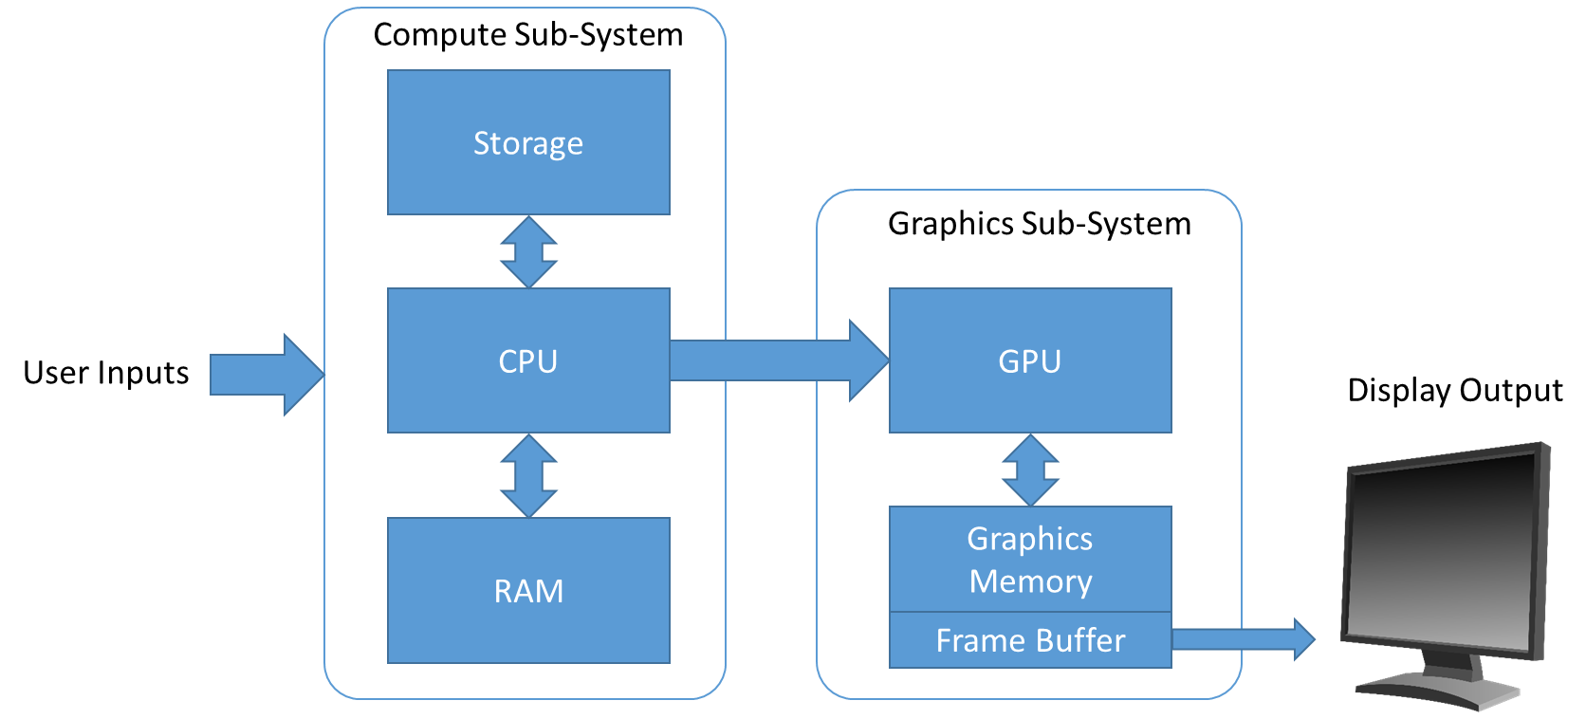

Figure 2: Computer System

The graphics memory is used to load/store data for processing by the GPU. A portion of the graphics memory contains the “Frame Buffer”, a dedicated block of memory where GPU writes the color values into the frame buffer. The display is set to read the color values in the framebuffer and present it as display output. The “Frame buffer” size is determined by the resolution (aka screen dimension) and the display mode type (ie., text mode or graphics mode) of the display output. In the early ‘80s IBM introduced Color Graphics Adapter (CGA) which supported text mode at 40x25 characters with 8x8 pixel font and graphical mode at 320x200 pixel resolution with 4 colors. The display is set to read the content of frame buffer at 60hz (ie.,60 frames per second).

The framebuffer content represents pixels in each row of the display starting from the top left of the screen as origin as shown below in Figure 3. Each pixel in the frame buffer is stored as either in few bits or few bytes based on the number of colors to be displayed. For example, a 256 color variation requires 1 byte to store each pixel value, a 64k color variation require 2 bytes and a 16.7 million color variation require 3 bytes (1 byte for intensity of Red, 1 byte for intensity of Green and 1 byte for intensity of Blue). Recent HDR display uses 10bit for each channel to represent 1.07 billion color variations for a pixel!

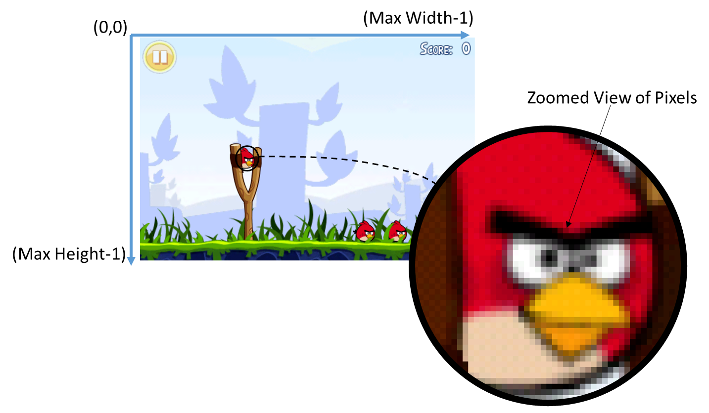

Figure 3: Screen coordinate system (Image source: Angry Bird game)

The following table (Table 1) shows some of the popular graphics display modes starting from CGA to the latest 8K resolution. A display device is characterized by the pixel density count, the number of supported colors as well as the display refresh frequency. For example, modern GPUs are marching towards supporting two 8K resolution displays running at greater than 90 frames per second (FPS) for Virtual Reality headsets. If each pixel in the 8K resolution requires 3 bytes, then the GPU must output (7680x4320*3 bytes) 99.5MB of frame buffer content for each display in the VR headset. So in 1 second the GPU writes about 17.9 Gigabytes (99.5MB*90*2) of framebuffer content!

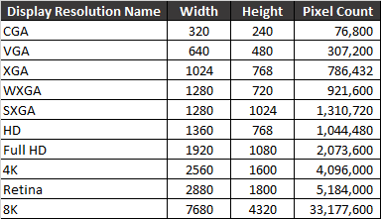

Table 1: Display Modes and Pixel count

### Transformation & Lighting Engine

The introduction of 3D games in the early 90s steered the need for 3D hardware accelerated 3D geometry processing in the GPU. Hence a geometry stage was introduced in the GPU which contains ‘Transform & Lighting’ (T&L) engine, the core foundation for the modern fully programmable GPUs and APIs such as Vulkan, OpenGL & Microsoft’s DirectX. The primary goal of T&L engine in the geometry stage is to transform 3D triangles into 2D triangles with clipping and lighting visible parts of the scene. The output of the geometry stage is connected to the Rasterization stage where the transformed and lit 2D triangles are rasterized and updated in the “Frame buffer”. The following diagram (Figure 4) illustrates a very high level overview of a fixed function GPU. Several low level details are purposely omitted to explain only relevant details.

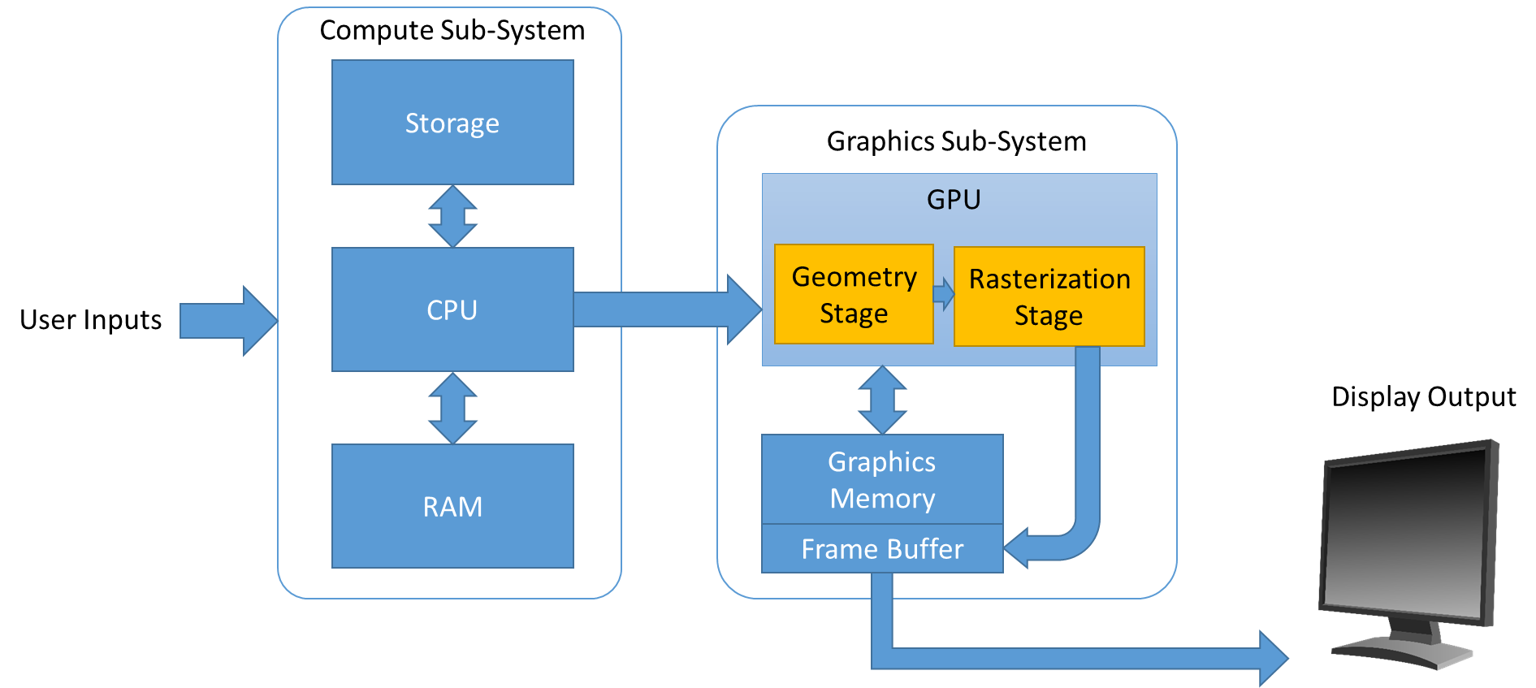

Figure 4: Fixed Function GPU

The Transform and Lighting engine contains a pipeline of processing stages as shown below in Figure 5. Each stage is connected to the next stage in the pipeline. The application can also program to skip any or all stages in the pipeline if needed. In such case the application is responsible for generating the transformed and lit vertices. In general when the application submits non transformed and lit vertices to the GPU, each stage in the T&L engine performs a certain operation and output the processed data to the next stage. In the end the T&L engine transforms all the vertices and apply lighting, projection, clipping and scaling as specified by the application and sends the transformed and lit vertices to the rasterizer stage in the GPU.

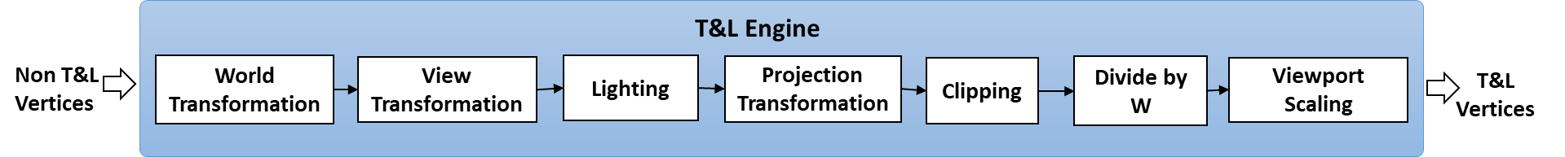

Figure 5: T&L Pipeline

The World Transformation stage is responsible for transforming 3D object’s local coordinate system to a world coordinate system. The transformation is specified as a matrix which is set to this stage to perform the operation. The matrix can use any combination of translation, rotation and scaling the 3D object in World space. The following figure illustrates a 3D object specified in local coordinate system and how it gets transformed into World coordinate system.

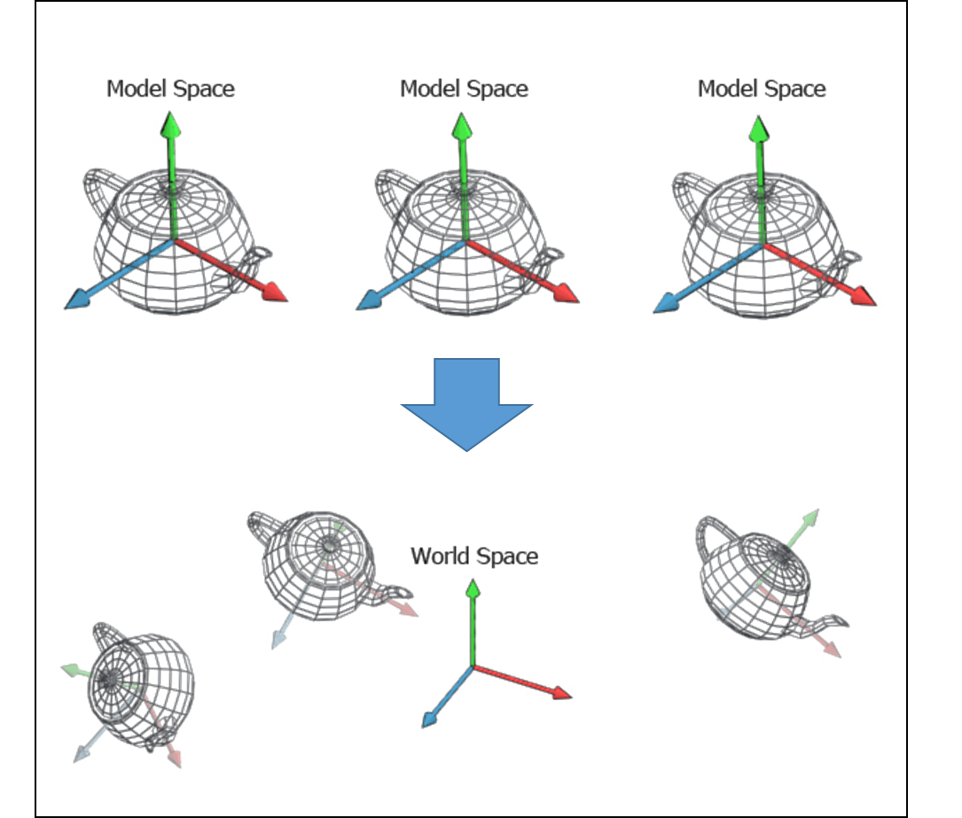

Figure 6: 3 teapots in Model Space to World Space (image source: http://www.codinglabs.net)

The View Transformation stage is responsible for transforming vertices of 3D objects and lights in the world space to camera space (also referred as eye space) as shown below. The camera space is defined using a virtual camera placed in the 3D scene and pointing directly down the positive or negative z-axis (based on the API used)

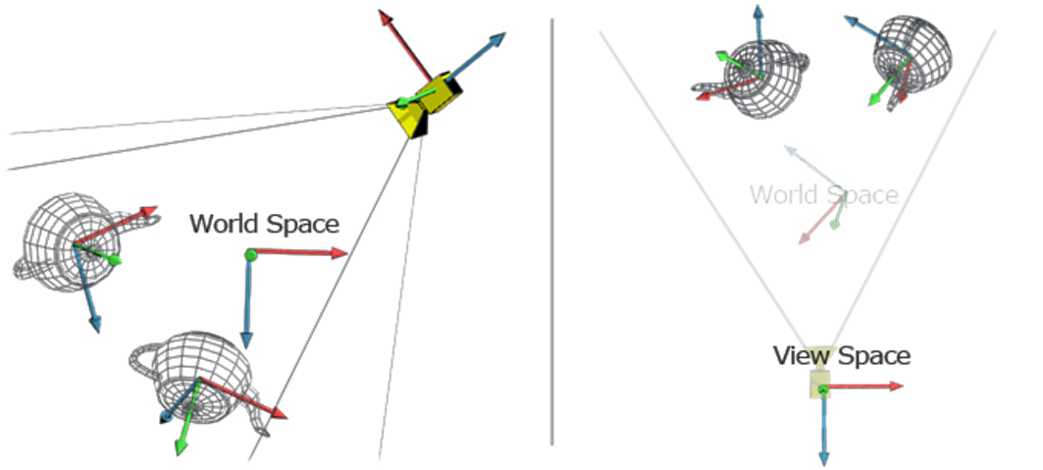

Figure 7: 2 teapot and camera in World space and in View Space (image source: http://www.codinglabs.net)

The Lighting stage calculates the vertex color value based on the current material properties, each of the light sources and their properties in the scene and stores the computed color value of the vertex back in the vertex data.

The Projection Transformation stage transforms the 3D vertex data in camera space to the projection space where objects are scaled based on distance from the camera’s point of view. There are 2 types of projection commonly used, Orthographic projection and Perspective projection as shown below.

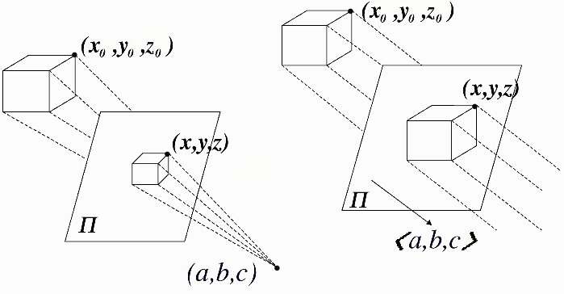

Figure 8: Perspective Vs Orthographic Projection (Image source: http://www.maa.org)

The perspective projection is widely used in gaming hence we will closely look at how the T&L engine perform this type of projection in the GPU. Perspective projection is defined by various parameters, to understand this we need to understand frustum as shown below. A frustum refers to a pyramid region defined from the camera point of view, where the size and length of the pyramid is defined by the field of view angle, aspect ratio of the viewport and the distance between the camera and the far clipping plane. A view frustum is a sub region within the frustum defined by the near plane and the far plane.

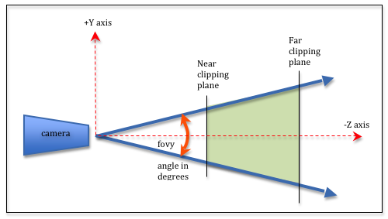

Figure 9: side view of frustum (image source: http://learnwebgl.brown37.net)

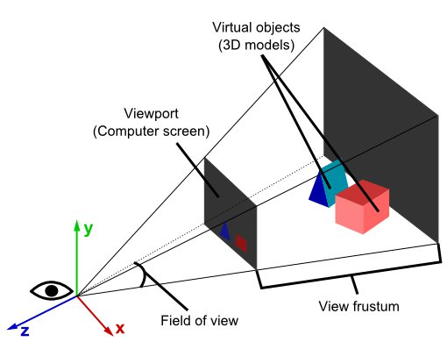

Figure 10: View Frustum (image source: http://www.real3dtutorials.com)

Clipping stage in the T&L pipeline is responsible for eliminating objects outside the viewing frustum. If there is any 3D object that partially intersect with the viewing frustum, then this stage in the pipeline is responsible for removing those triangles that are outside the viewing frustum. Triangles that partially intersect with the viewing frustum will be split into triangles to fit inside the viewing frustum as shown below

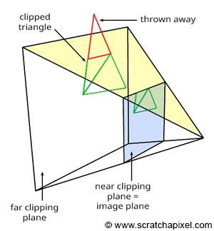

The triangles that passed the clipping stage enters into “Divide by w” stage, where the triangles in projection space are transformed into in to a new coordinate space called Normalized Device Coordinate (NDC) as shown below. Note that the near plane is at Z = -1 and the far place is at Z = +1 and the range of the cuboid is from (-1,-1,-1) to (1, 1, 1).

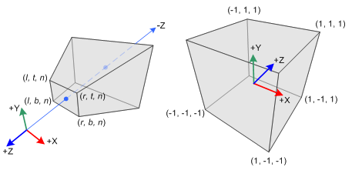

Figure 11: Perspective Frustum and NDC (Image source: http://www.songho.ca)

Viewport scaling is the final step in the T&L pipeline where the triangles defined within the NDC space is scaled and translated to fit into the viewport. Typically the viewport covers the entire region of the render surface. The following diagram illustrates the translation and scaling from NDC space to viewport.

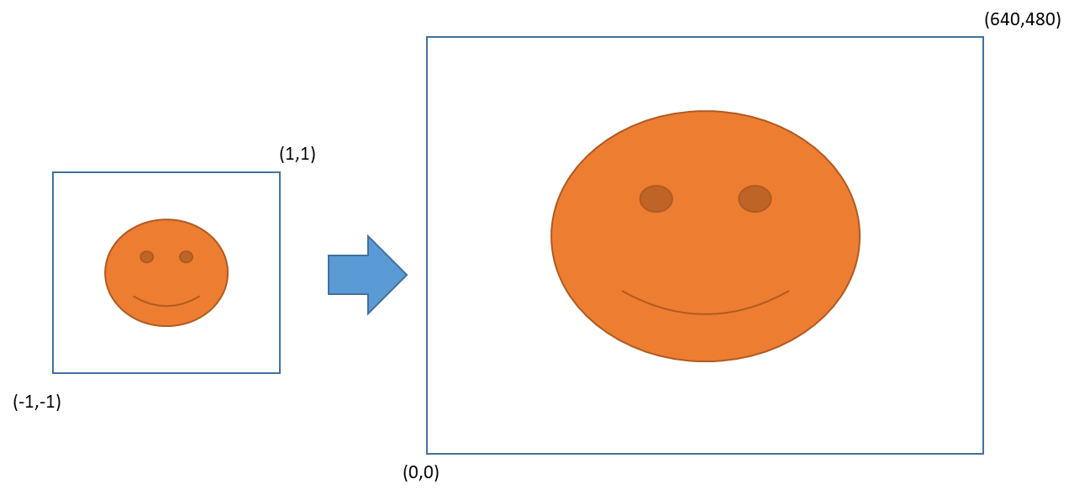

Figure 12: NDC to Viewport of 640x480 resolution

So far we looked at how T&L pipeline converts untransformed and unlit vertices into transformed and lit vertices. The following diagram describes how it fits into the Fixed Function GPU pipeline.

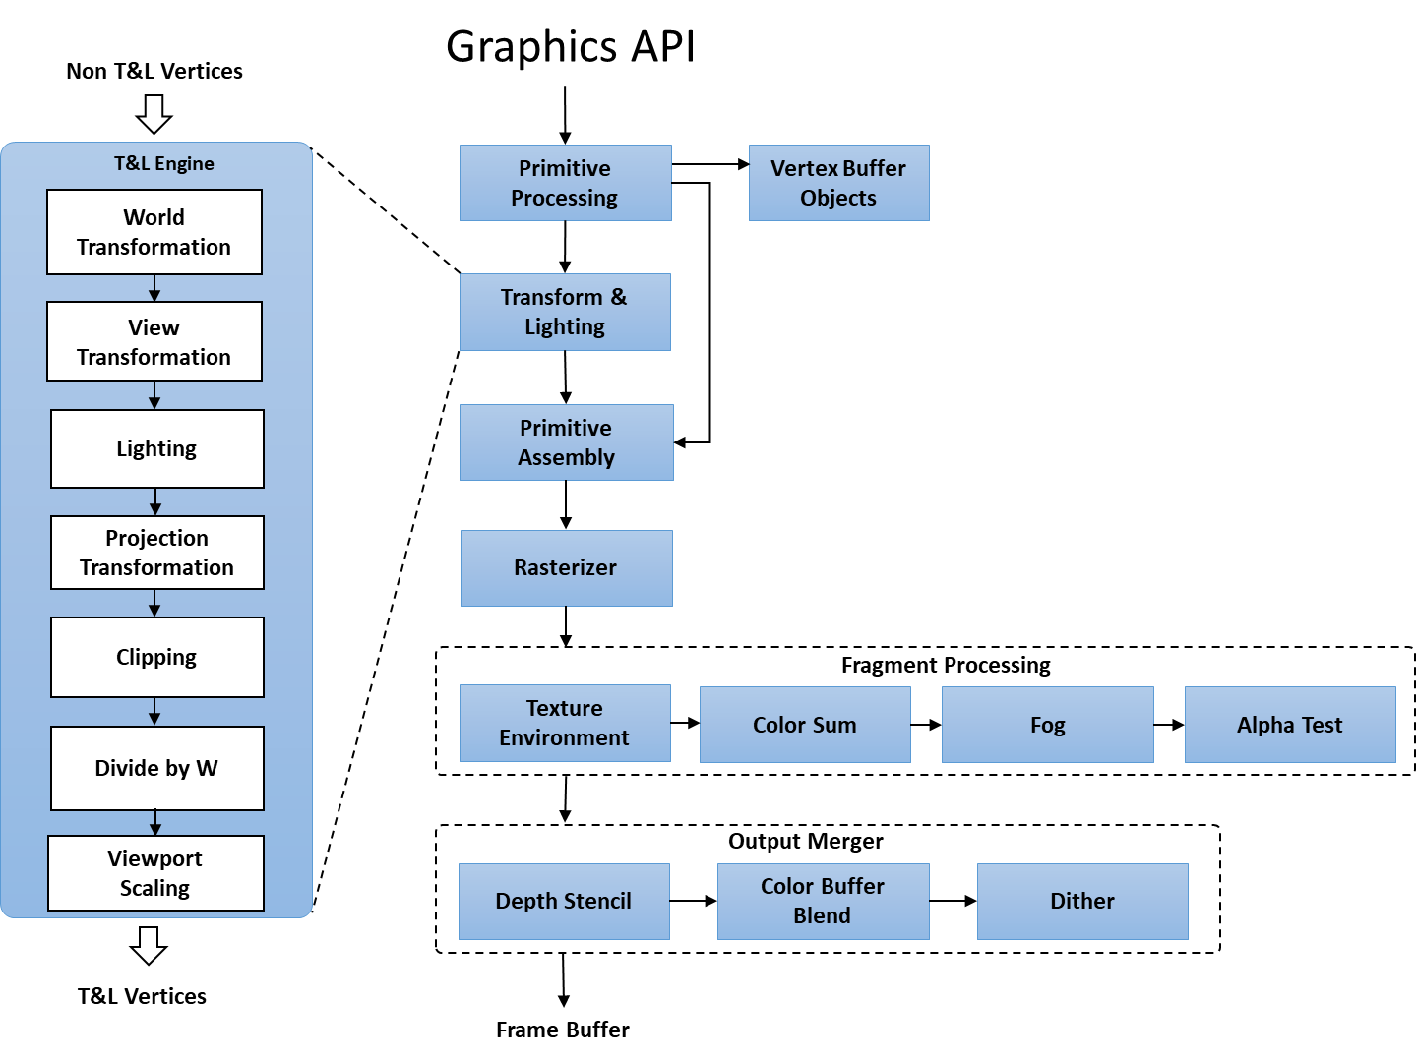

*Figure 5: Detailed Fixed Function Pipeline*

The output of Transformation and Lighting is fed into Primitive Assembly stage where a set of post vertex processing is performed such as converting vertex into point, line or triangle primitives; this processing performs any back-face culling and push the primitives to the Rasterization stage.

The Rasterization stage is responsible for converting triangles into fragments by interpolating each scanline in the triangle into a list of fragments. The interpolations occurs on coordinates, colors and normal specified by the triangle vertex.

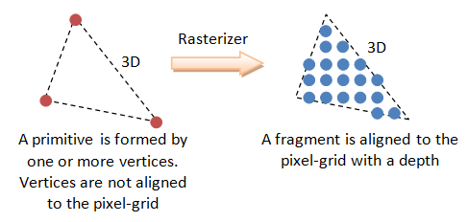

Figure 13: Triangle to fragments (Image source: www.ntu.edu.sg)

The output of Rasterizer stage is fed to Fragment Processing stage where texturing, lighting and special effects are applied at each fragment.

The processed fragments are sent to the “Output Merger” stage where a series of operations are performed on each fragment (such as scissor test, stencil test, depth test, color blending, masking and logical operations) before converting fragment into pixel in the framebuffer.

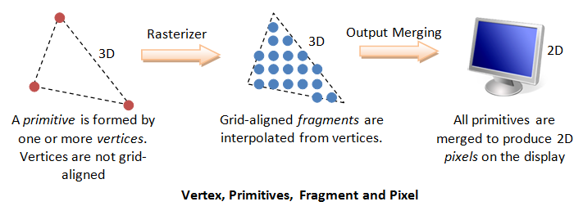

Figure 14: Fragments to Pixels in Framebuffer (Image source: www.ntu.edu.sg)

This section introduced the blitter engine and the T&L engine. These 2 are the core foundations for the modern GPU. The current GPUs are more powerful, have more programmable options and are also adapted to various types of computing devices such as laptops, desktops, phones, tablets etc.

## Types of GPU

In this section we will review 2 major types of GPU, Integrated GPU and Discrete GPU. Each has its own advantage and disadvantages based on various factors such as power, size, functionality etc. We will review them in detail in the following sub-sections.

### Integrated GPU

Integrated GPU also referred as IGP refers to on-board graphics found in many PC motherboards. They provide basic functionality & acceleration for the operating system to output visual content, including the GUI interface that most operating system supports by default. Over years IGP started adding additional functionality for casual gamers to play 2D and 3D games accelerated by the IGP. Some IGP provided acceleration for media workloads as well. IGP takes advantage of Unified Memory Architecture, where a dedicated portion of RAM is allocated for GPU processing needs. Since IGP are usually cost effective option and satisfies most graphics acceleration needs of a normal PC user they are most commonly seen on many PC desktops & laptops.

In the past IGP were usually found in North Bridge chip in a PC motherboard. North Bridge are commonly known as Memory Control Hub (MCH) or Graphics and Memory Controller Hub (GMCH). North Bridge is connected to the CPU via a high speed Front Side Bus (FSB) and provides communication between CPU, PCI Express or AGP external devices, RAM and South Bridge Chip.

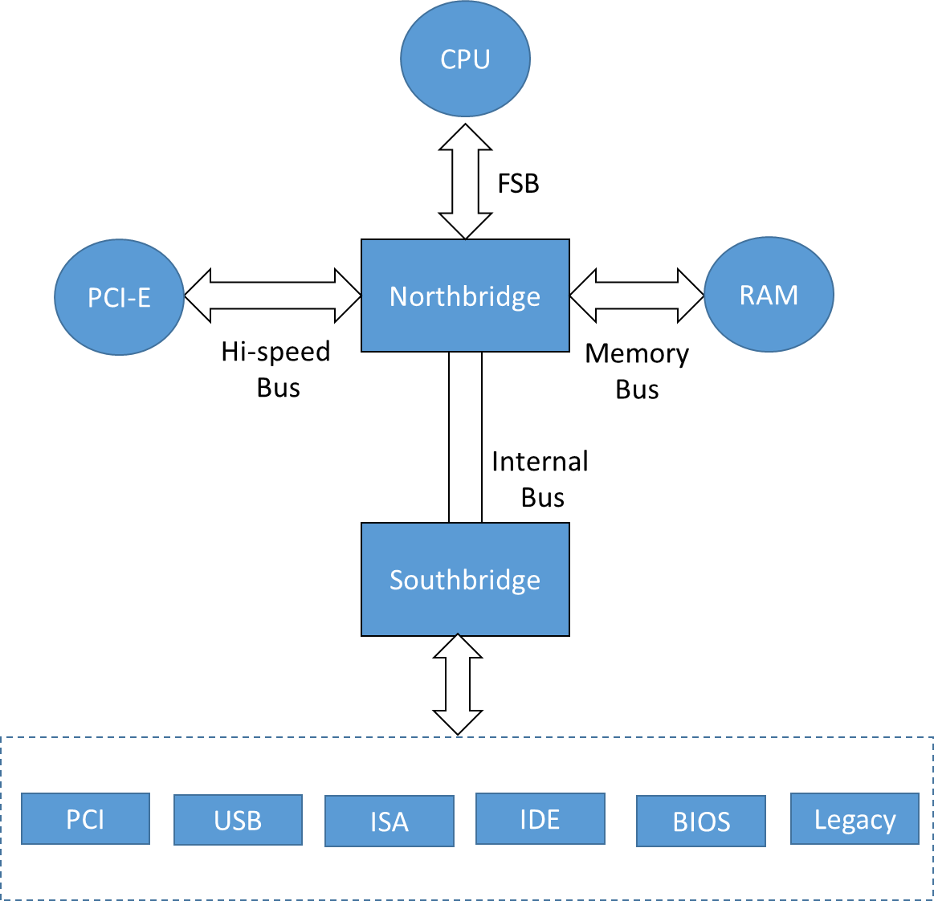

Figure 15: Motherboard components

The Southbridge chip usually handles communication with slow or legacy devices with the North Bridge. Southbridge chip is usually referred as I/O Controller Hub (ICH) in Intel based motherboards and Fusion Controller Hub (FCH) in AMD based motherboards.

In early 2011, Intel introduced ‘Sandy Bridge’ microarchitecture where GMCH (IGP and memory controller) are integrated into the CPU die to improve overall performance of the PC, including improved graphics performance, reduce latency and low power and low heat in the system. The integration also enabled processor to take advantage of latest CPU process technology such as 32 nanometer manufacturing process.

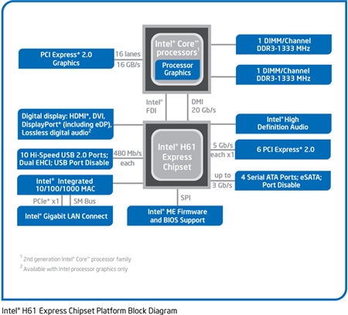

Figure 16: Intel Core Processor with Processor Graphics (Image source: Intel)

Recent generation of Intel processors integrated Embedded Dynamic RAM (eDRAM) for improved performance for gaming and heavy graphics workloads. Also as the graphics computation demand kept increasing year over year, the die space for Graphics and Media in the processor kept increasing as well. The most recent processors from Intel and AMD utilizes more than 50% of the processor die dedicated for graphics and media.

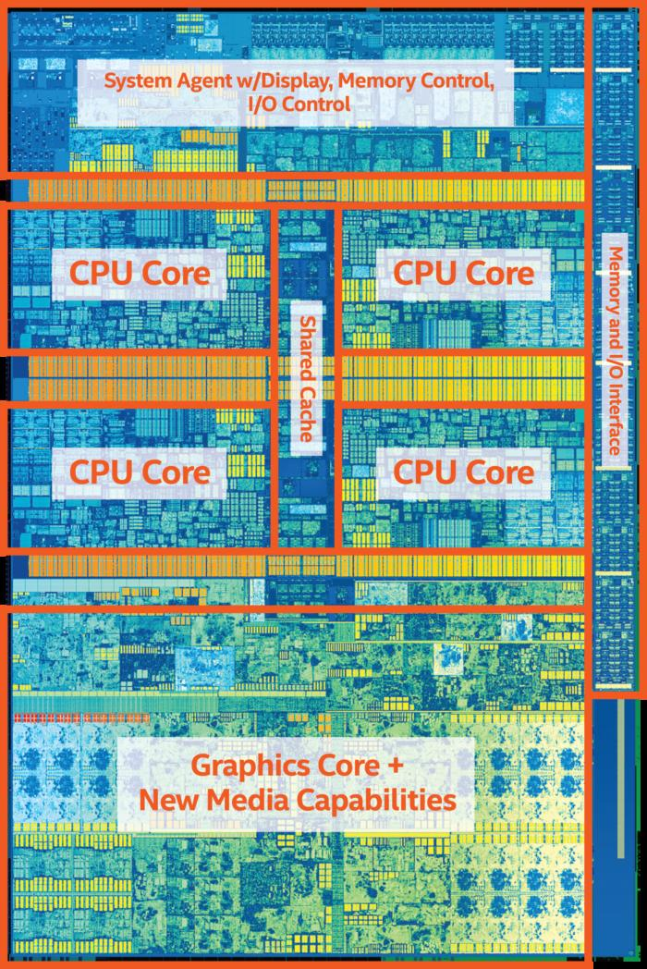

Figure 17: Intel Core i7 Processor 6700K components (Image source: Intel)

One of the main advantage of Integrated Graphics is that it can take advantage of Unified Memory Architecture with support for shared Low Level Cache (LLC), where a shared physical memory can be accessed by CPU and GPU without performing a memory copy operation from CPU to GPU or vice versa. This significantly saves power spent to transfer the memory as well as improve the overall performance of the system.

In summary IGP offers much better performance for light to medium graphics workloads with a very low power budget (typically <45watts to max 100watts). The recent IGPs also gone past the Tera-FLOPS (1012 Floating Point Operations per Second) barrier which were once only possible with Discrete GPUs.

### Discrete GPU

Discrete GPU refers to add-on video card or a dedicated chip with dedicated video memory in a PC. It is mainly used for high performance 3D gaming, General Purpose GPU (GPGPU) workload, heavy graphics and media intensive workloads such as video editing, video post processing, 3D modelling, high quality rendering etc. NVidia and AMD are the top companies that manufacture discrete GPUs.

The video cards are usually connected via PCI, AGP, PCI-Express etc. The most common video card connector is the PCI-Express with throughput up to 15.8GB/sec (PCI Express 3.0). Apart from providing high performance graphics, discrete video card also offers additional display outputs to connect multiple monitors or provide high resolution support such as 4K HDR display etc. A typical midrange discrete video card contains < 1 GB of video memory, couple of video outputs. A typical high end video card contains several GB of video memory, up to 4 or more display outputs and require additional power and heat sinks.

|  |  |
| --- | --- |
| High-end video card (NVidia 1080Ti) | * 3584 CUDA cores * 11GB Video Memory * 250Watts * 484GB/s memory bandwidth * Support Multi-GPU * 11 TFLOPS (FP32) |
| Mid-end video card (NVidia 1070) | * 1920 CUDA cores * 8GB Video Memory * 150Watts * 256GB/s memory bandwidth * Support Multi-GPU * 6.5 TFLOPS (FP32) |
| Low-end video card (NVidia 1050) | * 640 CUDA cores * 2GB Video Memory * 75Watts * 112GB/s memory bandwidth * Do not Support Multi-GPU * 1.8 TFLOPS (FP32) |

Table 2: NVidia GEFORCE series (source: NVidia)

#### Unique usages of Discrete GPUs

This section will introduce some of the unique usages of discrete GPU. Since most PC motherboards include multiple PCIe slots, some GPU vendors pushed the GPU technology to take advantage of many PCIe slots to bring better user experience with discrete GPUs. We will cover Multi-GPU, Hybrid Graphics and Multi-Display modes in the following sub-sections.

##### Multi-GPU

Some discrete video card provides scalability options where the graphics workload can be distributed between many cards in a PC to yield better performance or better quality output. AMD branded this as AMD CrossFireX technology and NVidia branded this feature as Scalable Link Interface (SLI).

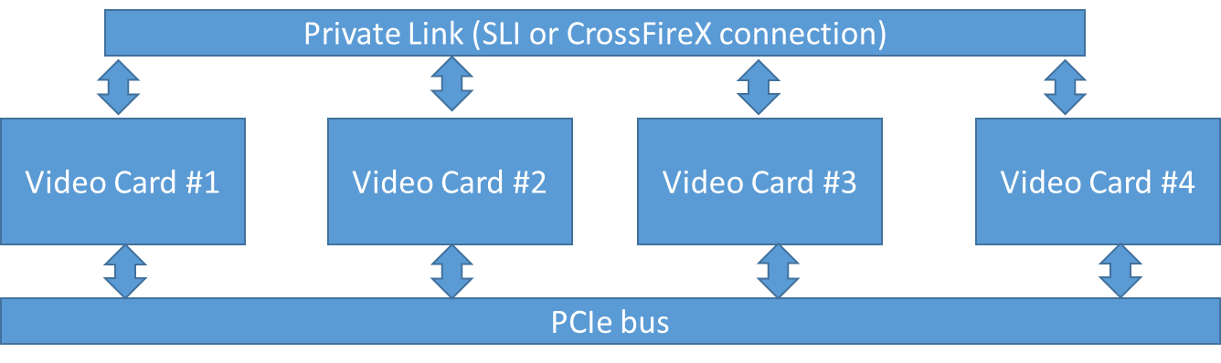

In Multi-GPU setup the graphics driver selects an appropriate rendering mode based on the 3D game or graphics application or automatically switches to an optimal mode based on the workloads. A master-slave configuration is used to distribute the workload and master card composites the final frame and display the output. The following modes are widely used:

* Alternate Frame Rendering mode (AFR): In this mode, each video card is assigned to render frames in sequence. For example in 2 video card setup, one card is assigned to render odd frames and the other card for even frames of the 3D game output. Though this mode yields better performance it also exhibits a glitch called ‘micro-stuttering’ defect which occurs due to irregular delays between frames rendered by each GPU.

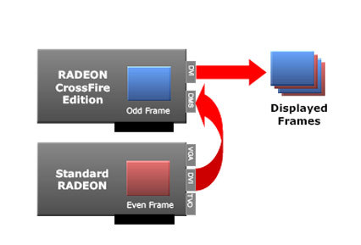

* Split Frame Rendering mode (SFR): In SFR mode each video card is assigned to process a particular split region of the frame. For example, in a 2 video card setup, one GPU is assigned to render the top half portion of the frame buffer while the other GPU is assigned to render the bottom half portion of the frame buffer.

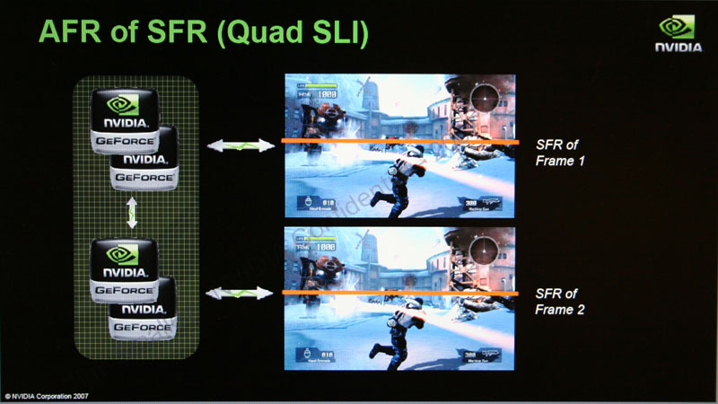

* SLI Anti-Aliasing: This mode is widely popular for generating high quality rendering without sacrificing performance. Multi-Sample Anti-Aliasing (MSAA) is a technique to soften the pixelated edges of the rendered 3D content by rendering each pixel at multiple sample frequency. For example, 8X MSAA mode means, each final pixel on the frame buffer is a cumulative result of 8 samples generated for that pixel. This is a highly compute intensive operation hence SLI AA mode enables much higher MSAA quality by splitting the workload between 2 or more GPUs and resolve the final high quality framebuffer using the sample results of each pixel from each GPU

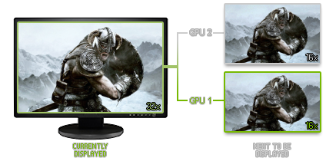

Figure 18: 32X MSAA using 2 GPU (Source: NVidia)

##### Hybrid Graphics

Since most PC comes with Integrated Graphics, Hybrid Graphics technology enabled a hybrid configuration (Discrete GPU + Integrated Graphics) to yield better performance when the system is externally powered or uses the Integrated Graphics for battery operational mode.

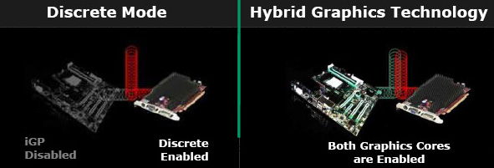

Figure 19: Hybrid Graphics on AMD (source: AMD)

##### Multi-Display mode

This mode enabled very large framebuffer support in 3D games, desktop and graphics application. Though most operating systems supports multiple display mode such as dual screen, extended desktop etc it did not support large framebuffer that span across multiple displays since it requires a clock sync between each display controller. AMD’s Eyefinity setup introduced in 2009 enabled support for 6 display output with each display set to 2560x1600 resolution. The recent version supports up to 24 4K displays (that’s a framebuffer with 199,065,600 pixels!)

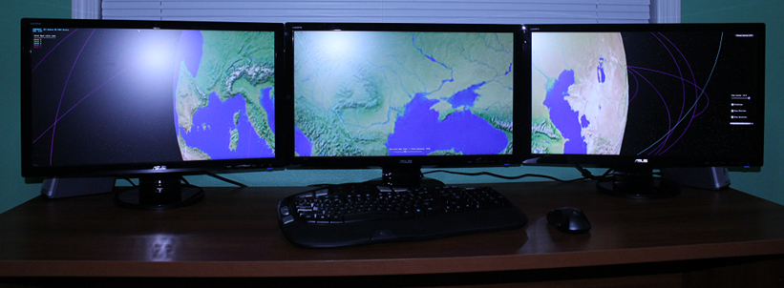

Figure 20: 3 monitor Eyefinity setup

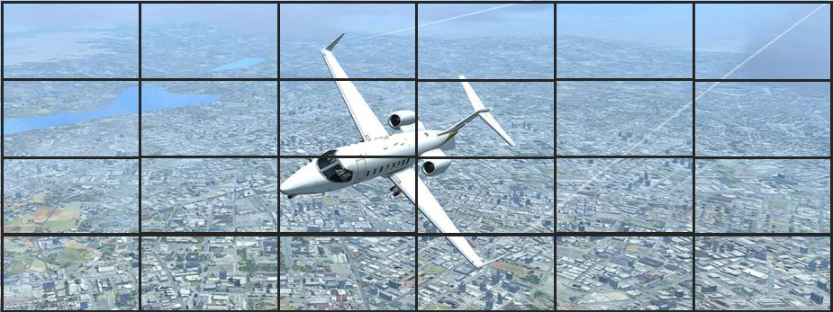

Figure 21: 4 AMD GPU powering 24 displays with 55megapixel framebuffer

A variation of discrete video card is the “Workstation Graphics card”, these graphics cards are specifically designed for 3D modelling, digital content creation, high-precision simulation etc. They are typically priced much higher than 3D gaming video cards for extended reliability, dedicated customer support and specialized driver implementation to handle workstation workloads more efficiently in the driver. AMD’s “FirePro” and NVidia’s Quadro are most popular graphics workstation brands in the market. These graphics cards also support Multi-GPU for improved performance, quality and multiple display output support.

The following table highlights some of the difference between integrated and discrete graphics:

|  |  |  |
| --- | --- | --- |
| **Features** | **Integrated Graphics** | **Discrete Graphics** |
| Form factor | Usually integrated in the motherboard or in CPU | Add-on cards for Desktop PCs or workstations |
| Power Usage | Typically between 4.5 & < 100 watts (CPU & IGP Combined) | Up to 300watts per video card |
| External Power | No. Usually powered by the motherboard or within the CPU. | High end card requires external power connectors, which sometime force the user to upgrade the PC power supply with high power throughput. |
| Features | Mostly supports limited features. Sometime additional features are implemented in CPU | High end cards are mostly full features and support the latest graphics API |
| Display support | Usually 2 or 3 Display out | Up to 6 display output per video card and with multi-GPU up to 24 displays (6 per display x 4 Video card configuration) |
| Cooling | Typically cooled by a normal cooling fan or passive heat sink based cooling system | High end GPUs require highly efficient cooling fan or oil cooling system |
| Price range | Typically low and priced as part of the motherboard or CPU | Moderate to High. Recent high end video cards are in $1000 range. |

## GPU Hardware Architecture

In the recent years both CPU and GPU are considered as computational processors, CPU are more optimized for low latency in instruction execution as well as data access, whereas GPU are more optimized for data parallel operation on highly parallel workloads such as 3D rendering or executing a same program/operation on large data sets.

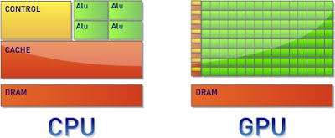

Figure 22: High-level block diagram of CPU & GPU

A typical high end GPU consist of 1000’s of programmable cores while a typical high end CPU consist of 6 or 8 processing cores that can run in parallel. The data cache is typically very large in CPU where as in GPU they are spread across programmable cores.

A GPU architecture mainly focuses on improving performance in 3 domain areas

* Graphics workload: This includes compute units for executing the various shader stages in a 3D pipeline.
* Compute workload: This includes compute units for processing data in a highly parallel fashion in the GPU and to seamlessly use the GPU cores for 3D graphics workloads
* DMA copy: This includes logics to efficiently copy data between GPU & GPU and within GPU.

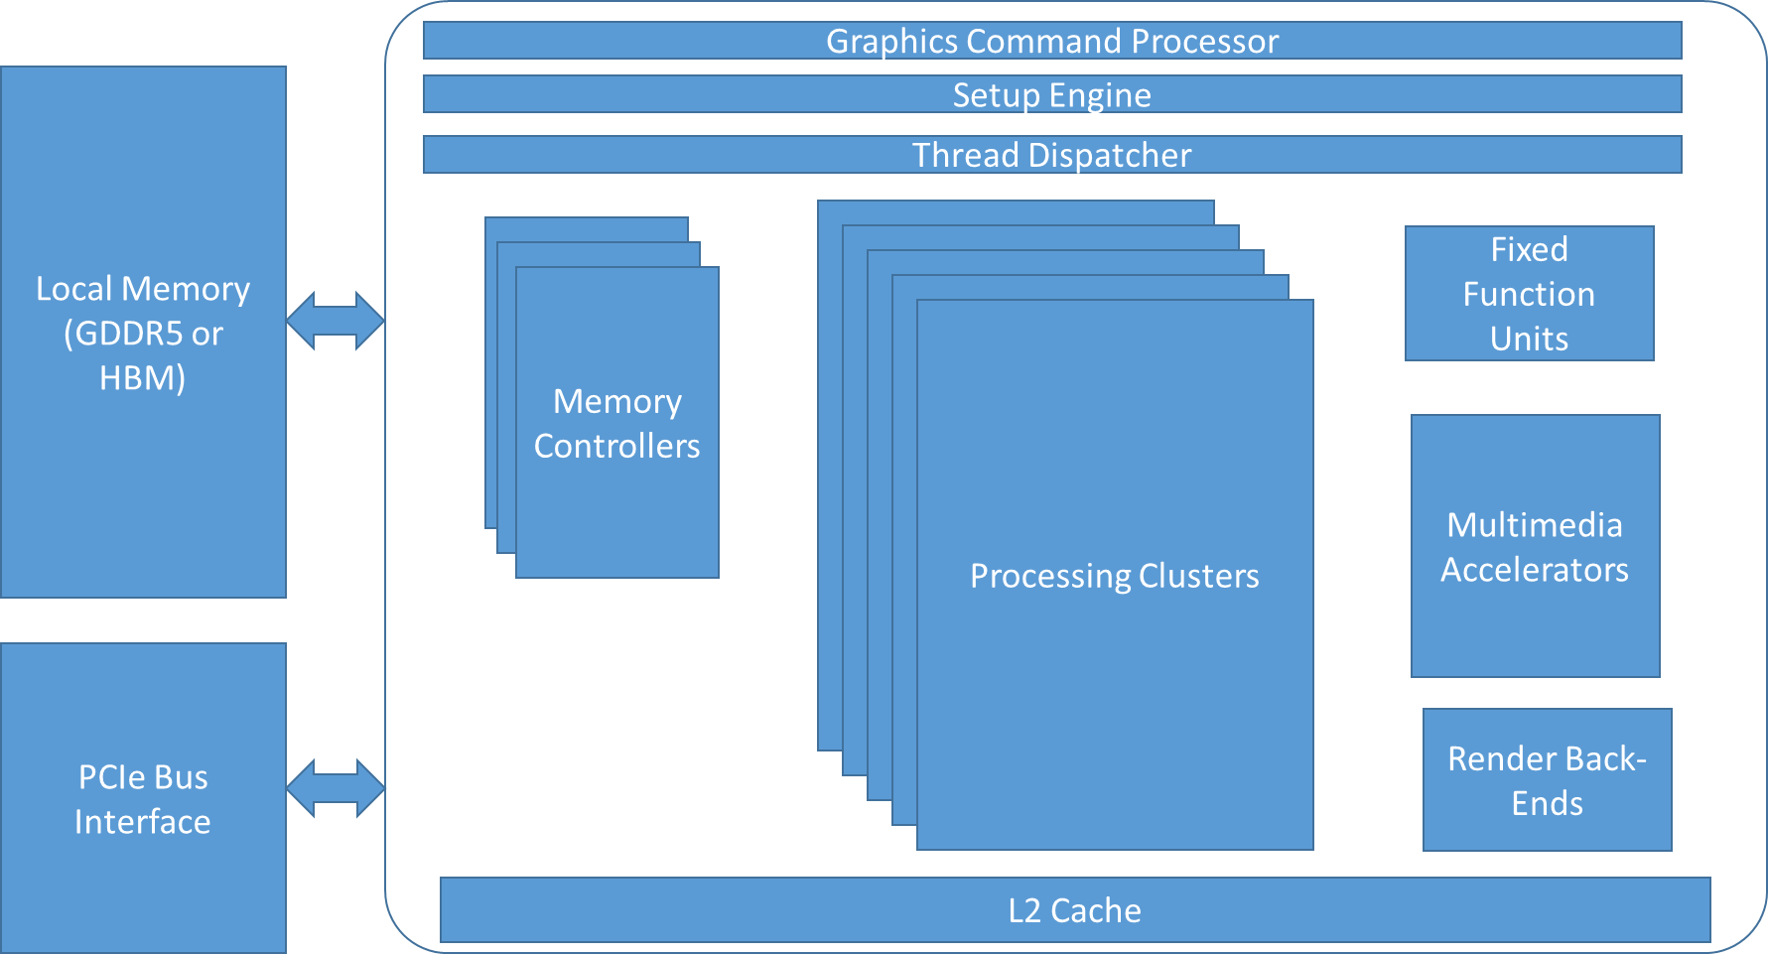

Figure 23: Generic architecture of GPU

While a detailed study on the GPU architecture is beyond the scope of this book, the above figure shows some of the main blocks commonly found in GPU. The command processor processes commands submitted by the graphics driver. The Setup engine prepares the data for processing and provides functions for vertex assembly, geometry assembly, scan conversion and interpolation. The thread dispatcher’s goal is to keep all processing units occupied.

### Processing Clusters

A GPU contains one or more Processing Clusters and each Processing Cluster contains a group of processing cores, fixed function units, texture sampler and local thread dispatcher as shown below. We will review some of the major GPU vendors’ processing clusters now

Intel’s Processing Cluster is called “Slice”. Each Slice contains 3 sub slice with 8 Execution Units (Processing Cores) as shown below:

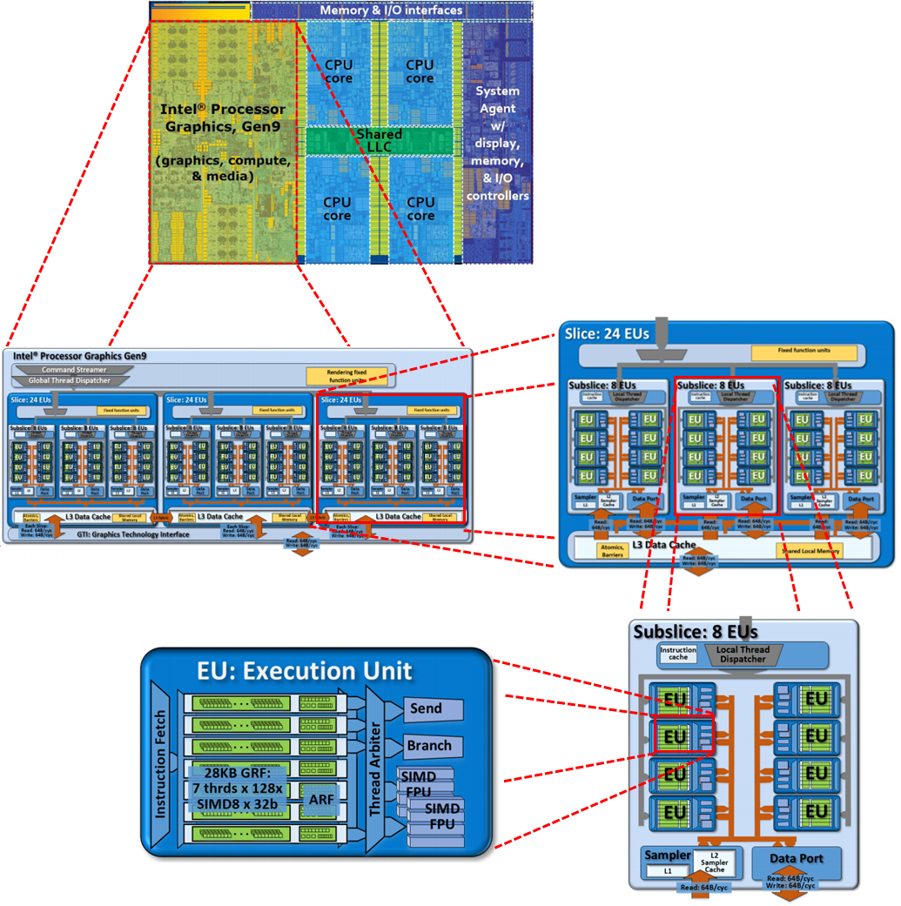

Table 3: Intel Gen9 Architecture (Source: https://software.intel.com)

A high end Intel Gen9 processor (Intel Iris Pro GT4e) contains a total of 72 EUs. Each EU contains 7 hardware threads, totalling 504 hardware threads in the 3 slice setup as shown above. Intel Iris Pro GT4e also includes 128MB of EDRAM (Enhanced Dynamic Random Access Memory) on the same package as the CPU to improve caching performance on DRAM access. The combination of 72 EUs at 1 Ghz core speed delivers an impressive 1152 Giga-FLOPS.

NVidia’s Processing Cluster is called “Graphics Processing Cluster” (GPC). A GP100 GPU contains 6 GPCs. Each GPC contains 10 Streaming Multiprocessor (SM). Each SM contains 64 CUDA cores, a total of 3840 CUDA cores and 240 texture units.

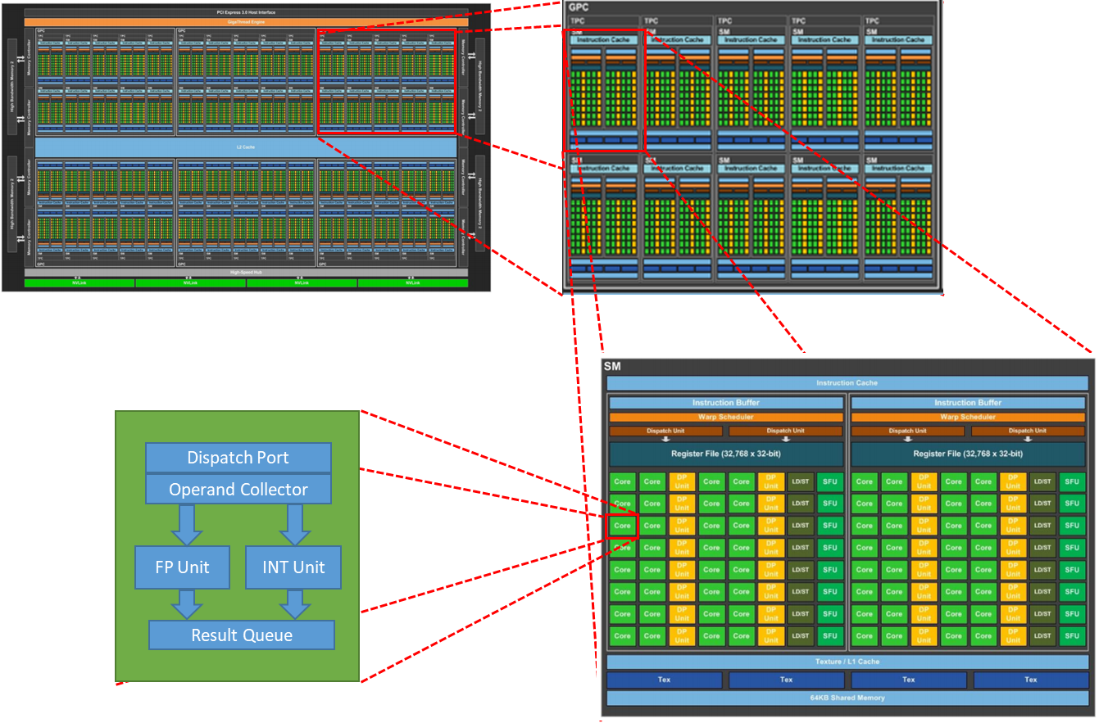

Figure 24: Nvidia Pascal GP100 GPU Block diagram (Source: NVidia)

SM is based on Pascal streaming multiprocessor that includes 2 partitions of 32 CUDA cores with each partition having its own dispatch units, a warp scheduler and large instruction buffer.

The immense power of 3840 CUDA cores and 240 texture units combined with high bandwidth memory (HBM2) with an impressive 720 GB/s peak bandwidth is accelerating games at 4K resolutions, Virtual Reality as well as Deep Learning workloads.

AMD’s Processing Cluster is called “Shader Engine” (SE). AMD GPUs contains 4 SE’s. Each SE contains a group of Compute Units (CU). AMD Fury R9 Fury contains 64 CUs (about 4096 stream processors). A high end AMD GPU has 8 Asynchronous Compute Engine (ACE) paired with a single graphics command processor to support Asynchronous shader, a technique in which both graphics and compute workloads can be processed asynchronously by the GPU. ACE enabled the GPU to process multiple compute and graphics tasks simultaneously to reduce latency and provide consistent frame rate.

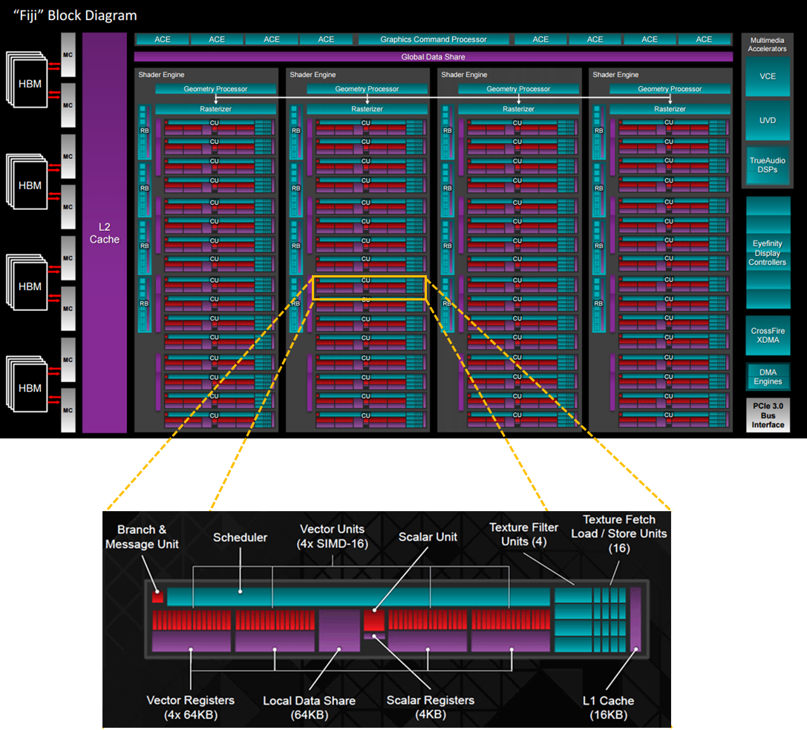

Figure 25: AMD Fiji Block diagram (Source: www.Guru3D.com)

## GPU Memory Technology

Beyond processing power of GPU, memory technology also plays a key role in delivering high throughput. Modern GPUs offer on-board memories of up to 12GB. The speed of the memory also varies based on the type of memory used. Integrated graphics that rely on system memory are often limited to DDR4 speed and can only have < 30GB/s of memory bandwidth while discrete video card with dedicated graphics memory (GDDR5 or HBM) can easily reach much higher bandwidth. The most recent video cards offer High Bandwidth Memory (HBM) which offers a bandwidth of up to 1 terabyte/second. GDDR5 is also more widely used in video card which offers over 650Gigabyte/second bandwidth.

HBM uses a stackable package architecture where as GDDR5 uses a single layer package. A 1GB of GDDR5 memory takes about 28mmx28mm area where as 1GB of HBM only consumes about 7mmx5mm area which can substantially reduce the video card size and consumes less power compared to GDDR5.

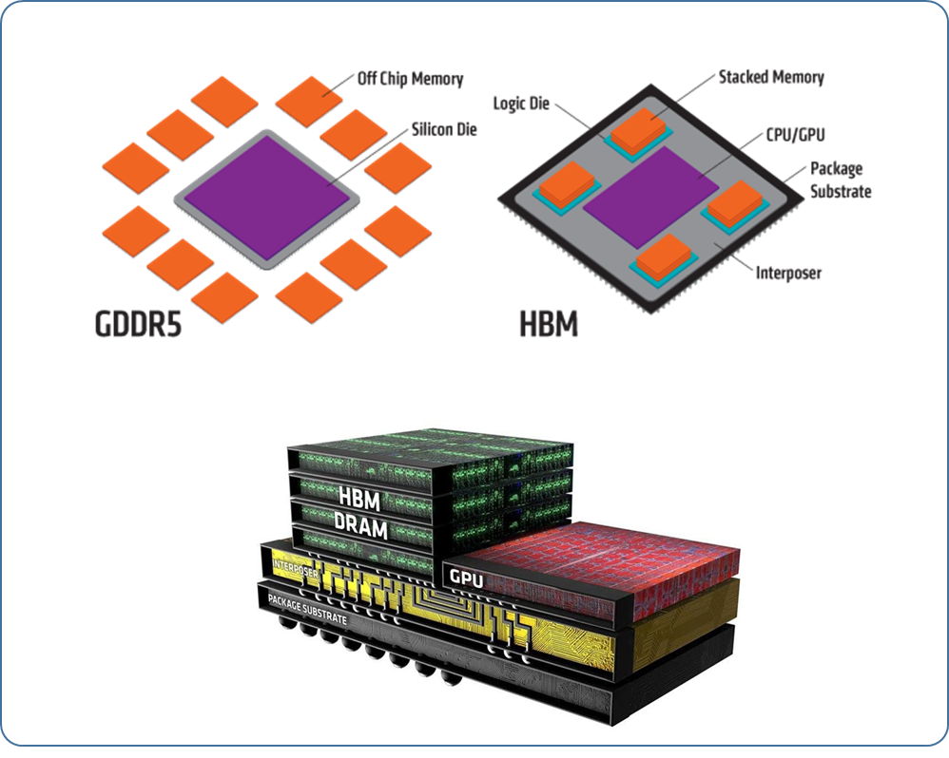

Figure 26: GDDR5 vs HBM (Source: http://graphicscardhub.com)

## Shaders

Shaders are computer programs (very similar to C/C++) that can be bound to various processing stages in the GPU pipeline. In a fixed function pipeline, an application is only allowed to set GPU states to alter the vertex or pixel pipeline. This limitation is eliminated with the introduction of shader to program the GPU. Shaders enabled applications to perform any kind of operation at 3D geometry stage, at every rendered pixels or even use GPU as a highly parallel data processing engine.

Typically an application defines the 3D scene with 3D objects, lights, textures etc. Shaders can be used to shade each 3D object or group of 3D objects in the scene. Shaders can access scene lighting information, materials, textures to process the 3D object’s geometry, generate new geometry as well as alter the color and attributes of every rasterized pixels before the GPU generates the final pixel output in the frame buffer.

The following diagram illustrates how a ‘C’ like shader code is turned into an optimized GPU specific binary code that GPU can execute in the 3D pipeline. Note that the GPU specific binary code is very specific to the shader type in the GPU.

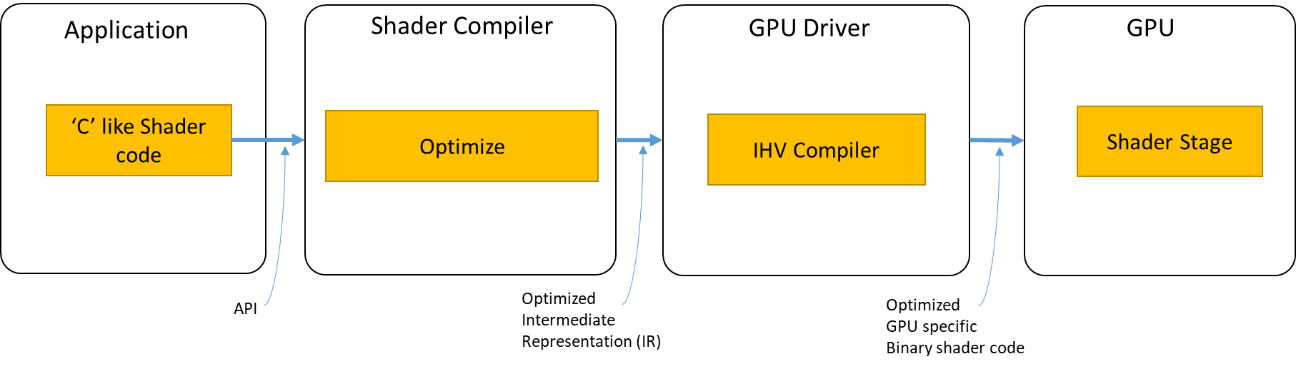

An application typically has many ‘C’ like shader codes. In order to use them in the GPU the application calls the shader compiler API to compile and generate an optimized shader code. Shader compilers are usually provided by the specific graphics Runtime module (for example Microsoft’s DirectX) or it can also be an open-standard compiler (for example SPIR-V from Khronos Group). The optimized intermediate representation of the shader (IR) is sent to the GPU driver where it goes through a series of architecture specific optimizations and hardware specific optimization and finally generates a binary shader code. When the application binds the shader, the corresponding hardware specific shader binary is bound to the GPU.

Here are some usages of shaders:

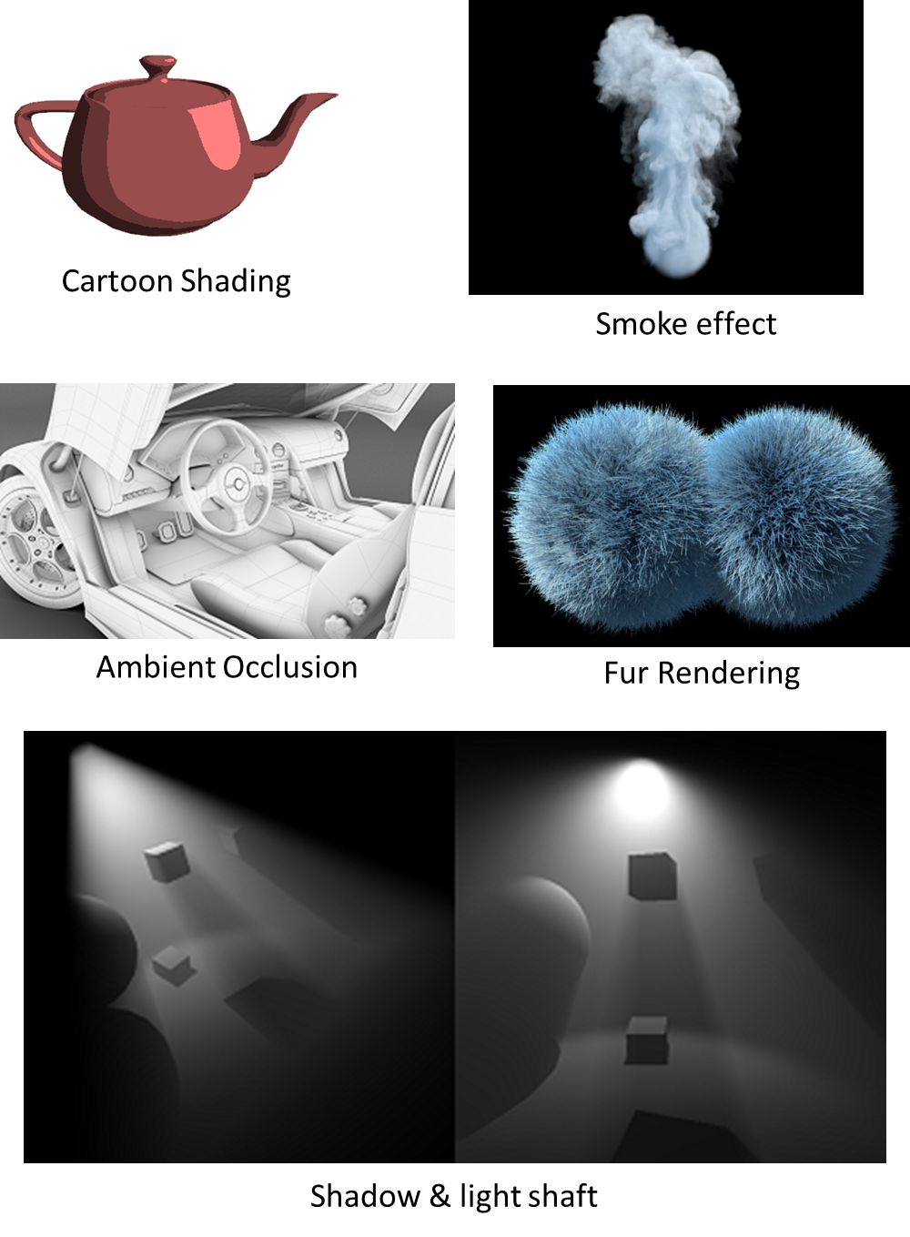

Figure 27: Shader usages

## GPU Processing Pipelines

In the previous sections we reviewed the hardware architectures as well as looked at shaders. This section introduces the 2 processing pipelines GPU supports, 3D graphics pipeline & the Compute pipeline.

### 3D Graphics Pipeline

In GPU a 3D graphics pipeline refers to a series of functional processing stages to render a 3D scene into a 2D image.

s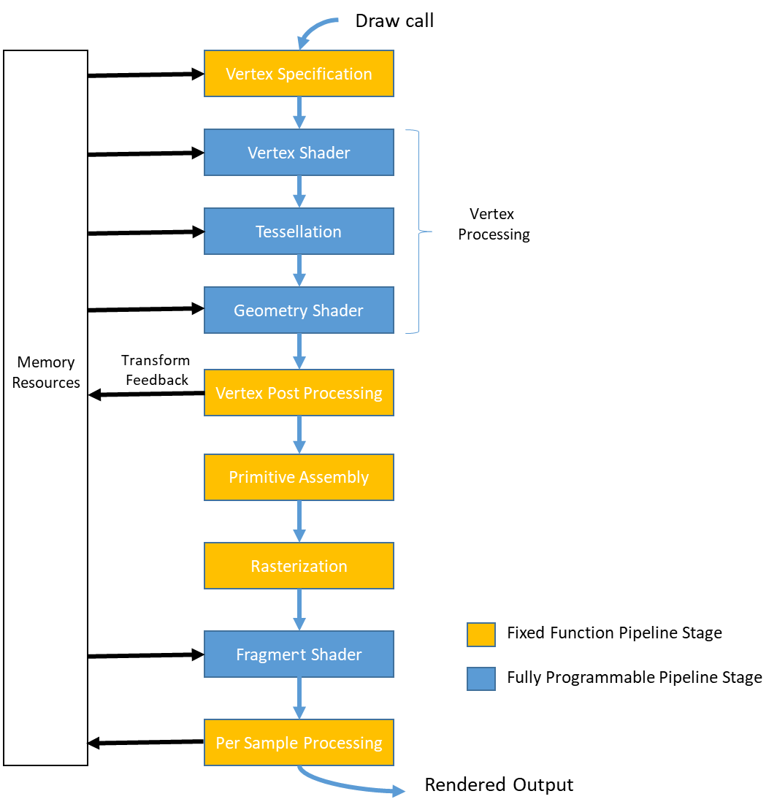

Figure 28:3D Graphics pipeline

An application sets up the 3D pipeline stage using the required input and output resources for each stages and calls a draw command. Once the GPU receives the draw command the following stages are processed in the given order. Some stages are optional and can be disabled before sending the draw command to the GPU.

**Vertex Specification**: This first stage is a fixed function stage in the 3D graphics pipeline where a set of configurable processing states are used to define this stage in the pipeline. The application sets up and binds the buffer objects containing the information of the 3D object to draw. This stage is triggered by a draw call from an application. The 3D object contains vertices which are represented using drawing shapes like triangle, lines or points. For example, a 3D object in a scene can be described using a set of triangles, which in turn are defined by their vertices. The application can define all the details of the vertex in a single buffer or a combination of multiple buffers. The data format, offset of each attribute is defined in a vertex array object (VAO)

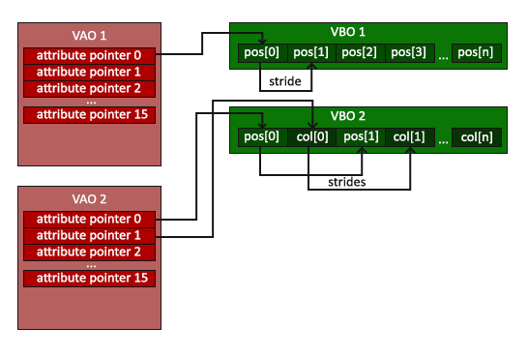

In the above example, VBO refers to Vertex Buffer Object and VAO refers to Vertex Array Object. VAO1 contains 1 vertex attribute about series of position data in VBO1. The stride denotes the size of the positional data in the buffer. VAO2 contains 2 attribute (position and color) and stride information of position and color data stored in VBO2.

**Vertex Shader:** This is the first programmable shader stage in the graphics pipeline which takes output of the vertex specification stage as input and executes a user defined vertex shader program on each vertex. The vertex shader provides unlimited control to manipulate properties such as position, color or texture coordinate of each vertex. For example, it can be used to transform a vertex positions defined in model space to projection space (ie., Model->View->Projection transformation), enable per vertex lighting calculation, vertex animations such as ripple effect, vertex morphing etc, process additional user defined per vertex data to pass it to the next stage in the pipeline. Modern GPU uses vertex cache to cache the vertex shader outputs to improve performance.

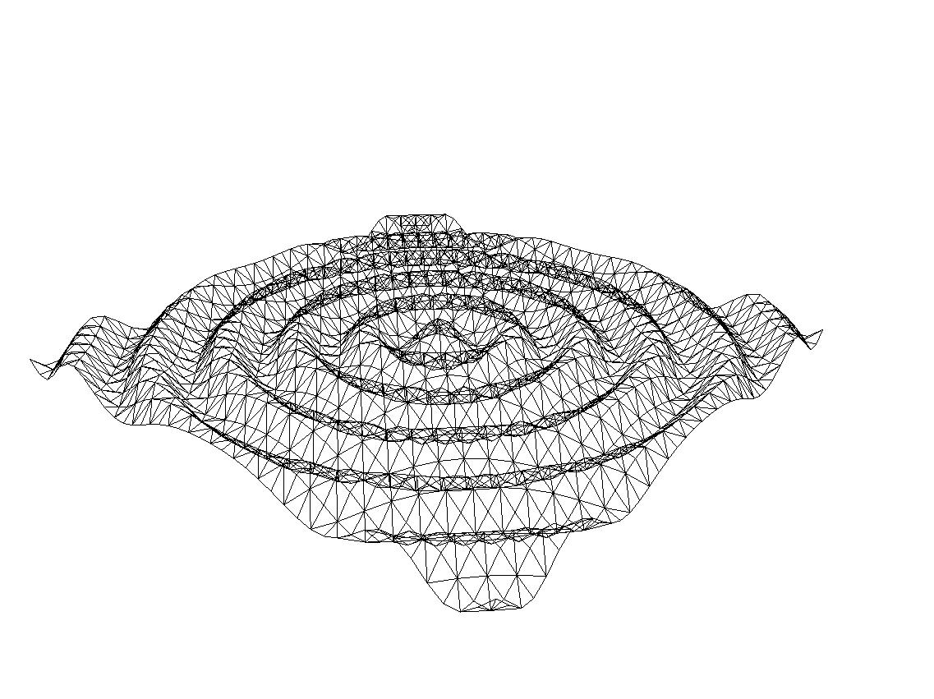

Figure 29: Ripple effect using vertex shader

**Tessellation:** This isan optional stage in the 3D graphics pipeline where patches of vertex data are subdivided into smaller primitives. This stage is divided into 3 sub-stages: Tessellation Control Shader (TCS), Tessellation Primitive Generator & Tessellation Evaluation Shader (TES)

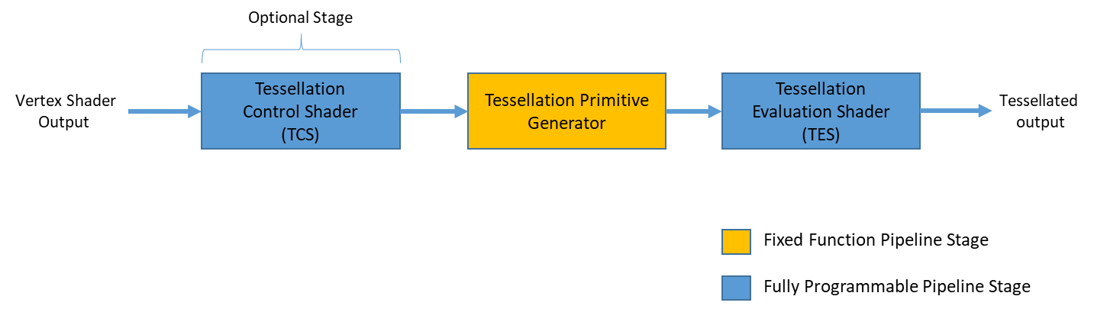

* **Tessellation Control Shader (TCS)**: This is an optional programmable stage that takes input from the vertex shader stage. This stage when enabled must determine the tessellation levels to be sent to the Tessellation Primitive Generator and generating data to be passed to the Tessellation Evaluation Shader (TES)
* **Tessellation Primitive Generator:** This is a fixed function stage which must be activated to enable tessellation support in the pipeline. This stage performs the breakdown of patches based on the level set by the TCS stage. When application disabled TCS stage then default tessellation values are used for this stage.
* **Tessellation Evaluation Shader (TES):** This is a programmable shader stage where it takes the tessellated patch and compute the vertex values for each generated vertex. This stage must be enabled when tessellation is used.

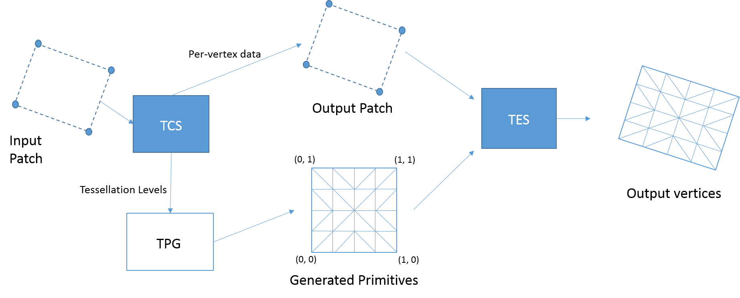

Figure 30: Tessellating a patch (Source: <http://victorbush.com/2015/01/tessellated-terrain/>)

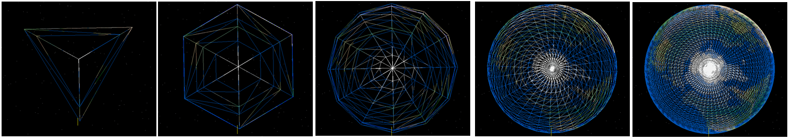

Figure 31: Rendering a 3D sphere in wireframe with Tessellation (Tessellation factor 3, 6, 12, 32, 64 shown)

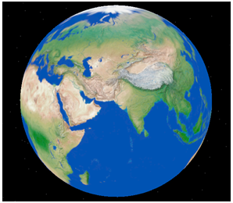

Figure 32: Fully rendered 3D sphere with texture using tessellated 3D mesh

**Geometry Shader:** Geometry shader stage is an optional programmable stage in the 3D graphics pipeline. This stage takes input from either the vertex shader stage (when tessellation is disabled) or from TES stage when tessellation is enabled. The shader can take primitives and add/remove or move primitives as shown below. The output of this stage is fed to Vertex-Post Processing stage to continue with the remaining of the 3D graphics pipeline.

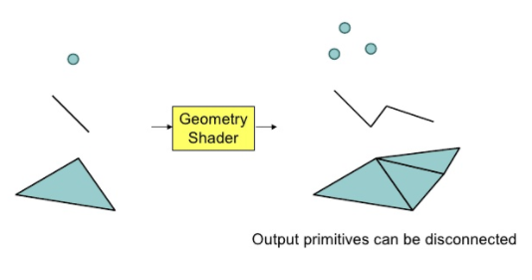

**Vertex Post-Processing:** In this stage the output of vertex processing pipeline goes through a series of post processing steps. This stage also allows the application to skip the remaining part of the pipeline and output the results directly into a buffer. If the application decide to execute the full pipeline then the following vertex post processing steps occurs in this stage:

* Clipping: Primitives passed by the application as well as primitives generated by the vertex processing stage are collected and then clipped to the view volume. Any points outside the volume is discarded by this stage. Also any line and triangle that are fully outside the volume are also discarded and any lines and partially in the view volume are clipped to fit inside the view volume and any triangle partially visible gets subdivided into one or more triangles within the view volume.
* Depth Clamping: In this stage application can control whether clipping can be performed against the Z position of a vertex.
* User-defined clipping: Application can set custom clipping parameters based on the usage, such as GUI window rendering where application can perform clipping at vertex level instead of pixel level at later stage in the pipeline.
* Perspective Divide: The clip-space positions after the clipping stage are transformed into normalized device coordinates (NDC)
* Viewport transform: The viewport transform performs the transformation of vertex positions in NDC space to window space.
* Viewport Array: Application can set multiple viewports and programmatically choose the viewport to choose using the geometry shader stage.

**Primitive Assembly**: In this stage the primitives that passed the vertex post-processing stage are divided into a sequence of individual base primitives and any primitives that are either not front facing or back facing as described by the application, are discarded..

**Rasterization**: As described earlier in the fixed function pipeline, Rasterization stage breaks down each primitives into discrete elements called fragments.

**Fragment shader**: This is an optional programmable stage if the application only cares about the depth and stencil values after executing a draw call through the full 3D pipeline. The shader program bound at this stage is executed at each fragment and can output depth, stencil, one or more color values etc. The inputs for the fragment shader either comes from system generated values or values interpolated by previous stages in the pipeline. Since fragment shaders are executed on each fragment, users must pay attention to operations that can be pushed up in the pipeline (ie., perform per vertex shading if needed rather than per fragment shading operation)

**Per-Sample Processing:** This is the last stage in the 3D graphics pipeline where the output of the fragment shader are processed and the results are written to the bound buffers. The following operations are performed in this stage:

* Pixel ownership test: When the application is rendering the content in a window app, often times another window could occlude part of the rendering window, in such case this stage discards pixel writes that are occluded by the other window. If the application is running in full-screen exclusive mode or when rendering to a texture this operation is ignored.
* Scissor test: Application can setup a rectangular region with in the destination framebuffer for valid rendering, any fragments aimed at pixels outside the rectangular region gets discarded at this stage.
* Multi-sample operations: Multi-sample operation can be used to obtain high quality rendering by performing anti-aliasing operation on the triangle or line edges. Modern GPUs supports enabling fragment shader to perform at pixel frequency or at sample frequency, thus when 8X MSAA is enabled fragment shader is executed 8 times for each sample.

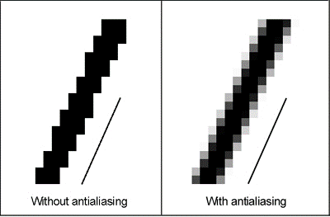

* Stencil test: This test is used to discard a fragment based on a bitwise operation between fragment stencil value and the stencil value stored in the current stencil buffer. Applications use this feature to generate shadows for 3D objects in games and graphics application.
* Depth test: Depth test is similar to stencil test, where it allows a fragment to be discarded based on a conditional test between the fragment’s depth value and the depth value stored in the active depth buffer at that fragments sample position.
* Occlusion query update: Queries provides a mechanism for application to understand what operations are performed and what operations are discarded by the GPU. Occlusion query is one example to detect whether an object is visible.
* Blending: In this stage the fragment color output is combined with the colors in the color buffer using user provided blending operations. The resultant color of the operation is stored in the color buffer. One great usage of Blending is to enable transparency in rendered objects.
* sRGB conversion: This stage is for converting color values in linear color space to color values in non-linear color spaces.
* Dithering: In this stage colors that are represented in high precision floating point values are converted to normalized integer image format.
* Logic operations: This stage provide support for performing logic operations on the fragment color value with the corresponding color value in the frame buffer.
* Write mask: This allows only certain color components to be written to the output buffer. Each output buffer contains mask to discard all or certain components of the color output.

Modern GPUs allow to perform a subset (pixel ownership, scissor/stencil/depth test, occlusion query update) of these operations before the fragment shader execution for better performance.

### Compute Pipeline

Modern GPUs includes 1000’s of compute cores. Compute pipeline provides a way to repurpose cores in the GPU for accelerating highly parallel workloads. Games and graphics applications can also use the compute pipeline to perform non-graphics workloads such as for physics simulation, data processing that are normally done using CPU. One major advantage of compute pipeline is that application can queue combination of 3D and compute workloads. For example, the output of a compute workload can be fed as input to a 3D workload or vice versa. This enables GPU to work independently without synchronizing with CPU. Modern game engines use the Compute pipeline for deferred lighting, Particle effects, fluid dynamics, ray tracing etc, hence combination of 3D & compute provides more realistic rendering using the GPU.

A compute pipeline is rather simple compared to a 3D graphics pipeline as shown below. Application binds a compute shader to the GPU and calls an API to execute the compute shader with the given input and output buffers. The GPU schedules the work to all available cores to perform the operation in parallel and output the result in one or more output buffers. Since several cores can simultaneously execute the compute shader in parallel the work gets done much faster in the GPU.

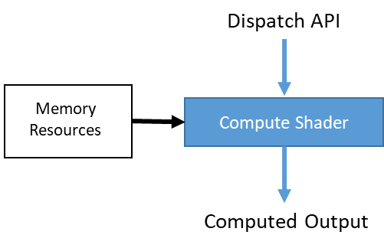

Figure 33: Compute Pipeline

A compute shader code contains instructions to execute on a single thread in the GPU. Hence to better assist application to decompose the workload, a hierarchical thread structure is used to define thread and its index. A thread is defined with a 3D index with in a work group. A collection of threads is denoted as work group and each work group can be identified with its 3D index. The compute shader can compute the active thread index using the active workgroup index (x,y,z) and the active thread within the workgroup index (x,y,z). The compute shader can also synchronize threads with in a work group. For example, After all the threads in a work group performed an operation, one thread can synchronize all the results and write out to the output buffer.

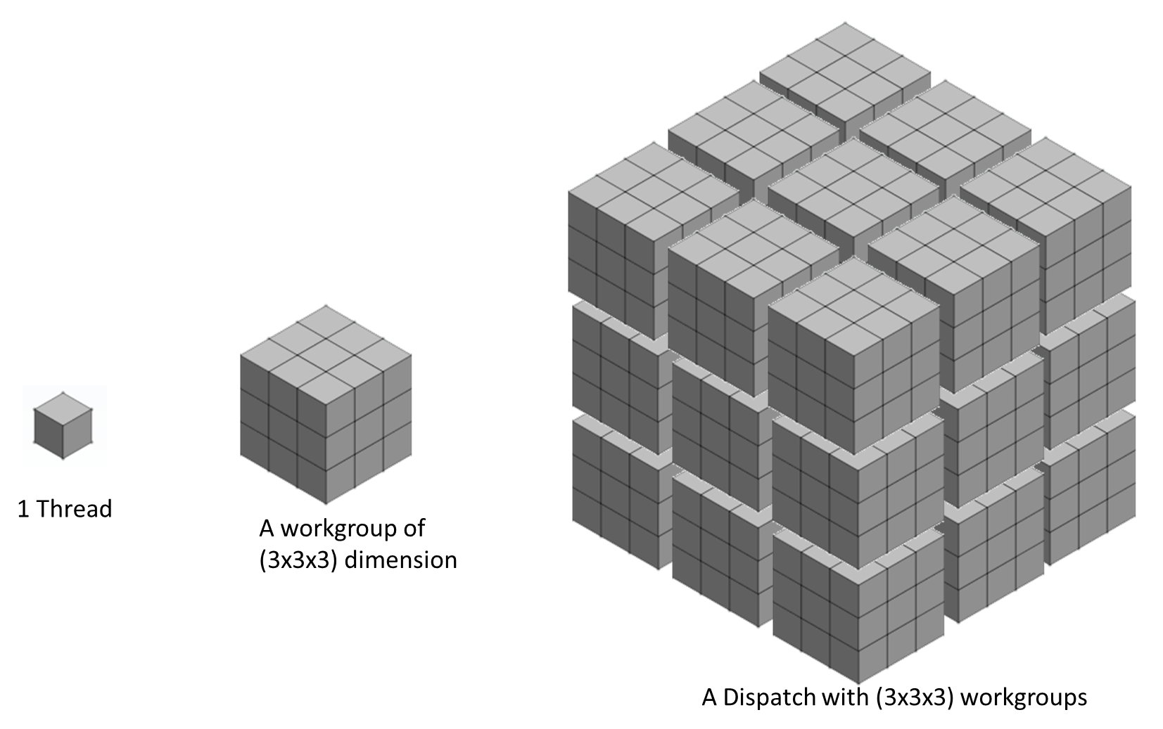

Figure 34: Thread representation in a Compute pipeline

In the above diagram, A Dispatch with (3x3x3) work groups and each work group with (3x3x3) threads spawns a total of 729 threads ( (3x3x3) x (3x3x3) = 729 ) in the GPU. Depending upon the GPU architecture a set of threads execute in parallel in each compute cores in the GPU.

Each thread can work on a particular portion of the workload and write out the result to the output buffer. The portion of the input memory & output memory is calculated based on the active thread index.

Compute pipeline can be used to perform ray tracing, a technique for generating more realistic rendering by tracing the path of light through pixels in an image place and perform hit test with 3D objects.

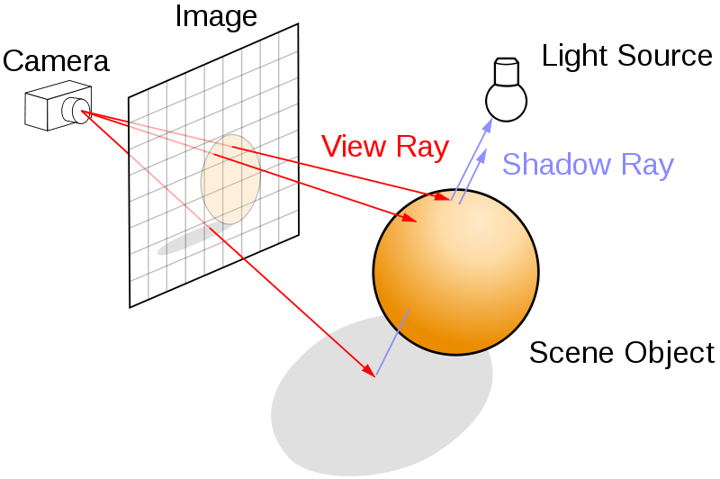

Figure 35: Ray Tracking setup

For example, a frame buffer of 640x480 resolution requires 307,200 rays for hit test alone. We can split the framebuffer into multiple 32x32 size grids. To convert this into a Compute shader workload, we can have a 20x15x1 work groups where each workgroup is 32x32x1 in dimension. Each workgroup processes 32x32 pixels in the frame buffer.

In this section we reviewed the 3D graphics pipeline & the compute pipeline support in the GPU. An application can submit workloads to both the pipeline simultaneously or create dependencies of one pipeline output with the other pipeline, for example in the above raytracing example, the application can choose to render the 3D scene using the 3D pipeline and use the output of the 3D pipeline as one of the input to the compute pipeline to generate high quality shadows or perform advanced lighting techniques. We will review this technique in detail and apply them in the examples we are going to build in the following chapters.

## Application Programming Interface

This is the last section in chapter 1, where we are going to see how an application submits workload to the GPU. The following diagram shows an overall graphics software stack and a set of components interconnected to take application workload to the GPU.

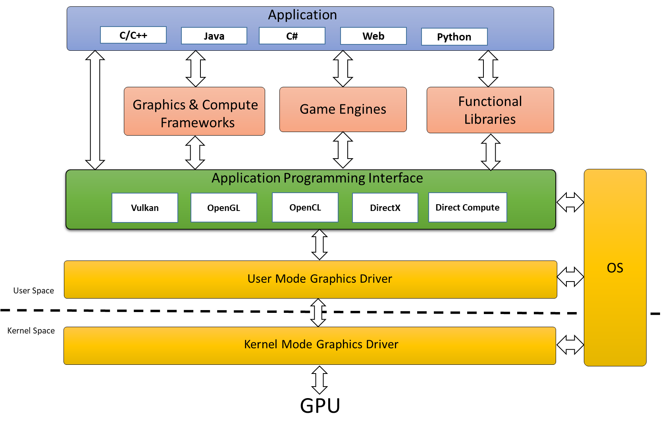

Figure 36: Graphics Software Stack

An application can be 3D game, simulation application, visualization application or Data processing application written in any supported programming language or scripting language. Depending up on the programming language used some applications can access the Application Programming Interface (API) directly to submit work to the GPU. Vulkan, OpenGL & OpenCL are open standard APIs from the Khronos Group and DirectX and Direct Compute API are from Microsoft developed for Microsoft Windows platform. Several Graphics and Compute Frameworks are also available with high level APIs to submit graphics and compute workloads. For example: Openframeworks, Cinder are some high level creative frameworks to develop graphics & GPU accelerated compute applications. Several game engines and gaming platforms are also available for application developers to access the GPU (Unity3D, Unreal engine etc). The GPU hardware vendors also provide Functional libraries to access the GPU for special case workloads such as accelerating Deep Learning on the GPU. There are several APIs currently available for graphics and compute workloads and some are OS specific (DirectX / DirectCompute) and some are GPU vendor specific (CUDA). In general APIs are responsible for submitting the application request to the graphics driver. The graphics driver itself is split into user mode graphics driver and kernel mode graphics driver. The user mode graphics driver builds the command buffer based on the list of calls received from the API layer. The kernel mode driver converts the command buffer to a DMA buffer and submit to the GPU. When a workload is submitted to the GPU it generates a rasterized output or generate an output buffer for the compute workload.

## Summary

GPU is one of the most complex piece of hardware with a complex API in a PC. This chapter covers some of the basics of GPU that a developer must be aware of while developing an application that uses the GPU. The following chapters will cover some of the GPU hardware features in details and guide you to use them in the application we are about to build using Vulkan API.